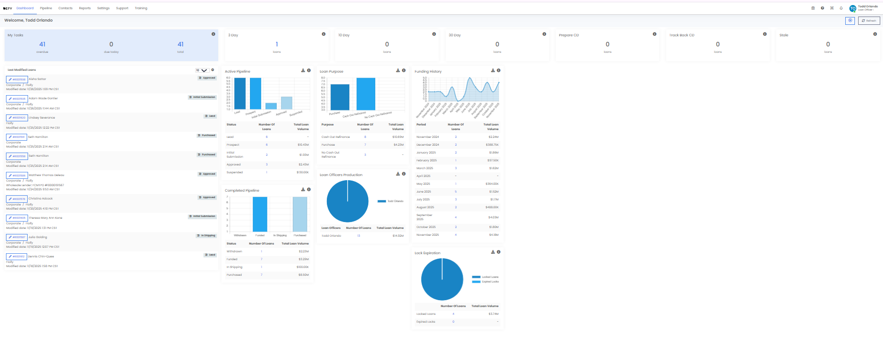
Pipeline view Example
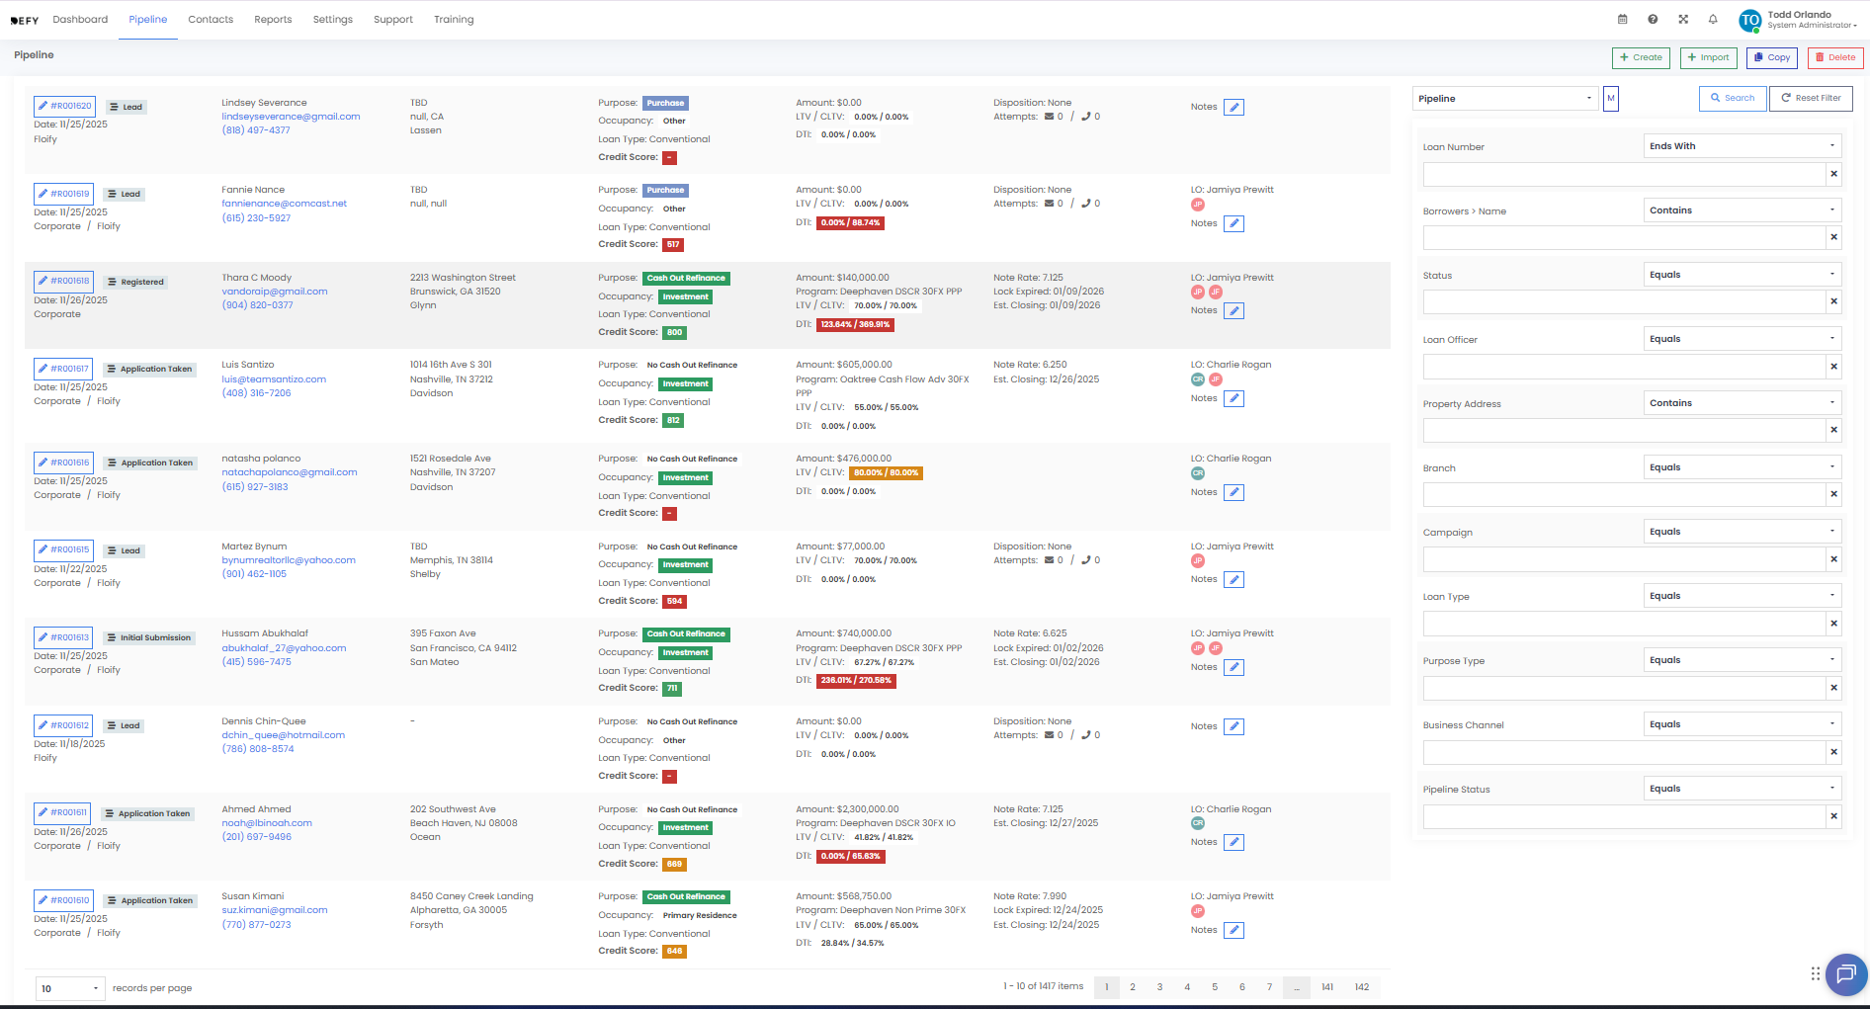

Contacts Primary Tab View
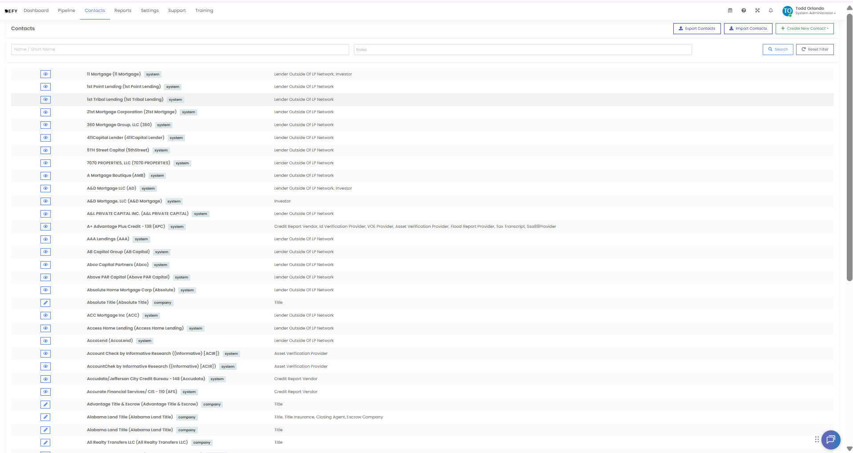
Add New Contacts View (manual Add)
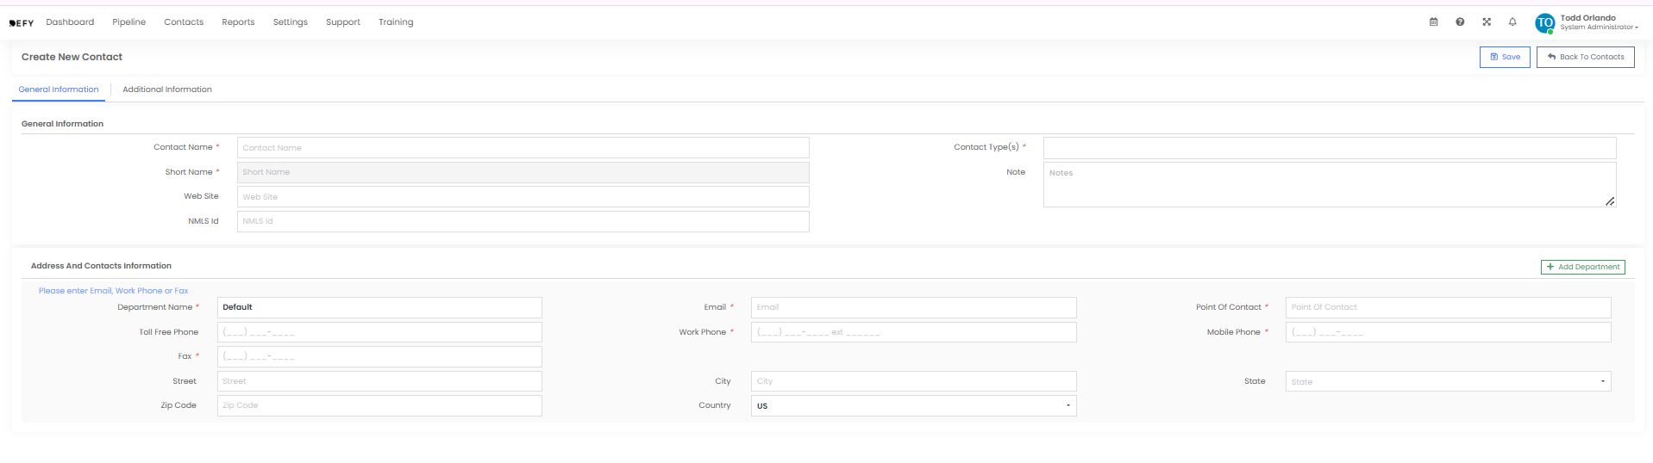
Add Contact (IMPORT View)
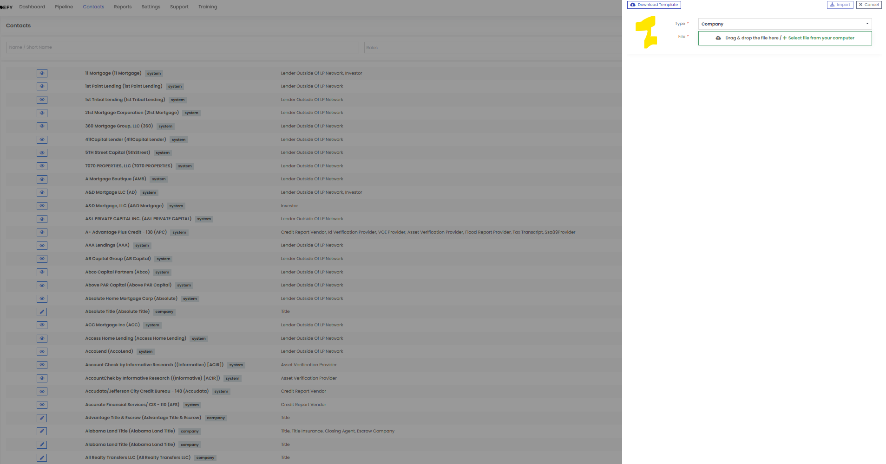
Export Contacts Will Create a CSV file with all the data in this section
REPORTS TAB VIEW -
|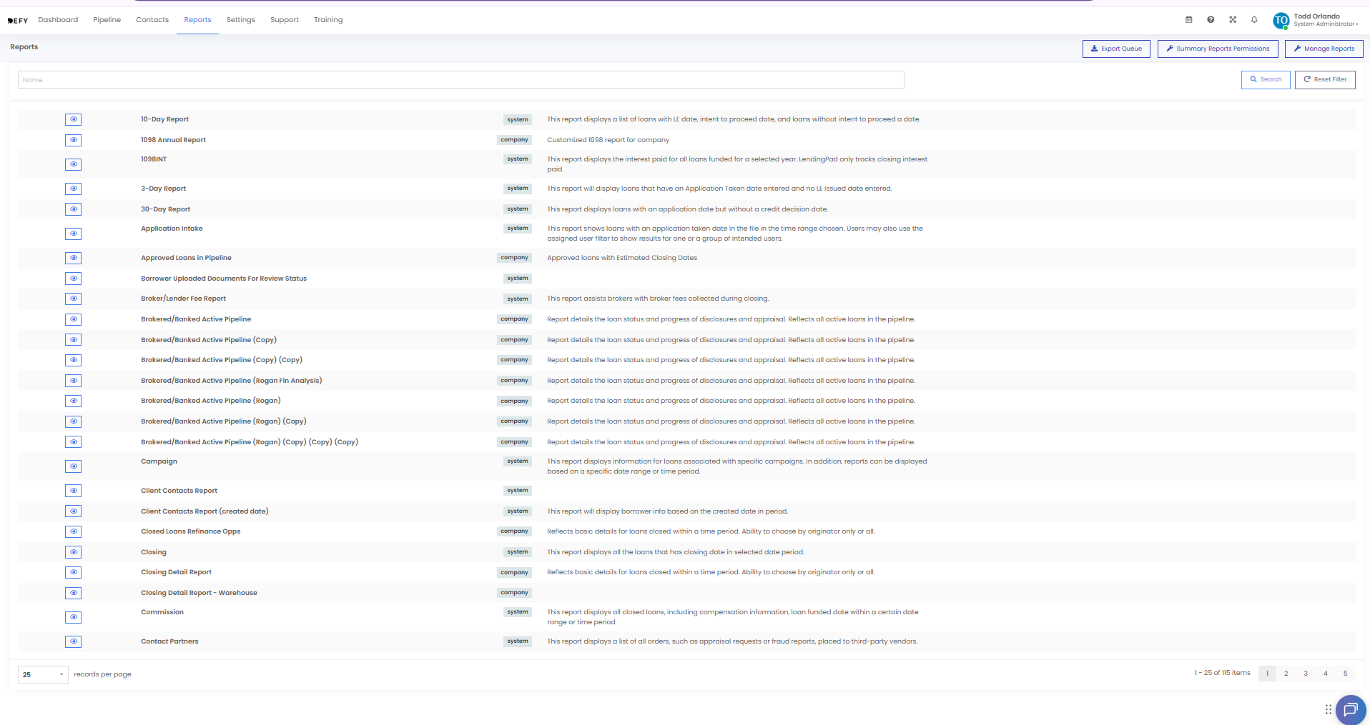
Permissions
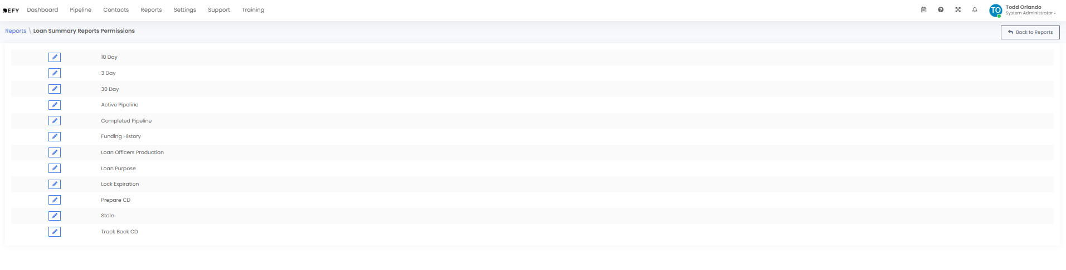
Manage Reports and Acc Custom Reports
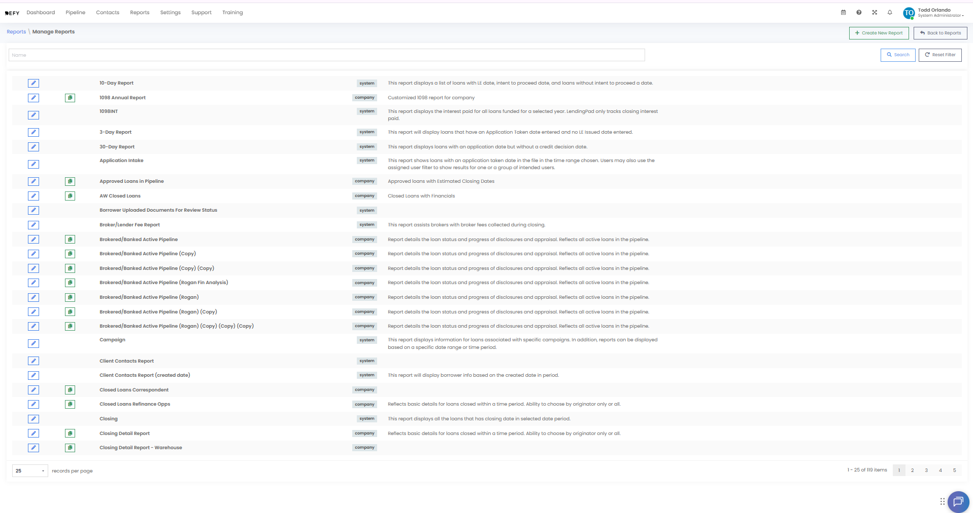
Settings Primary view
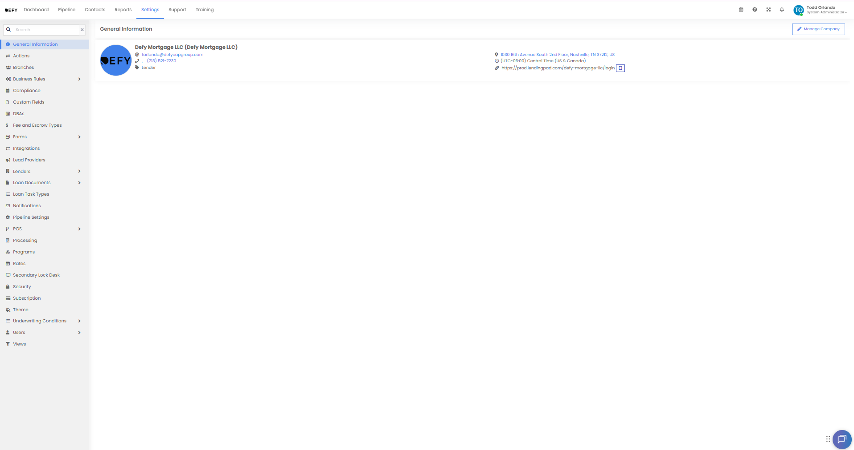
Help – Desk view
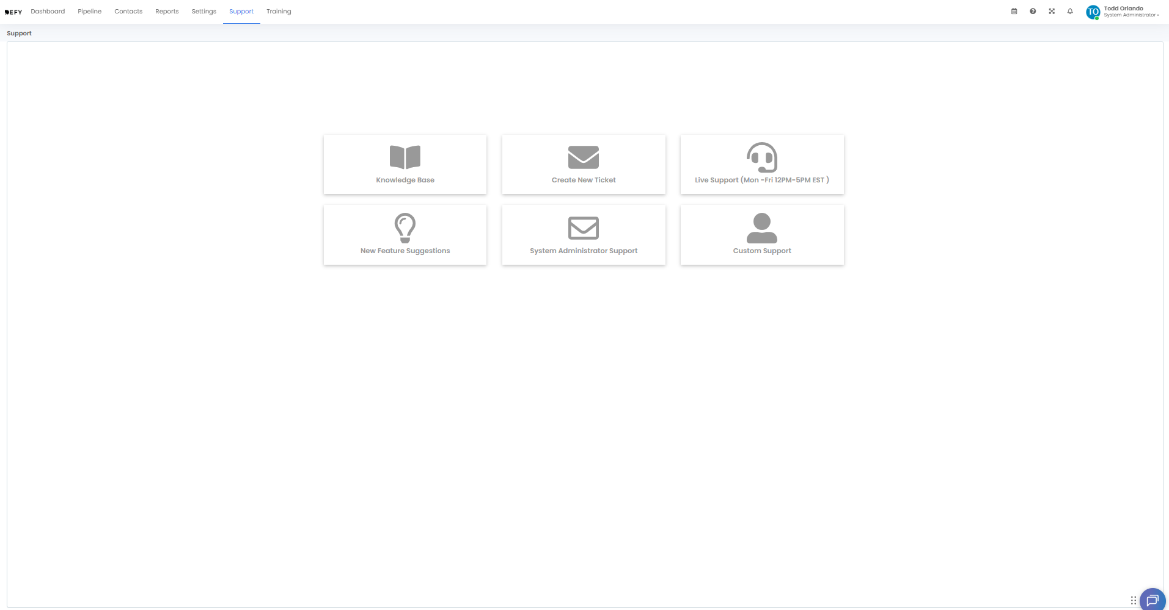
Training Page wth Custom Vids and guides
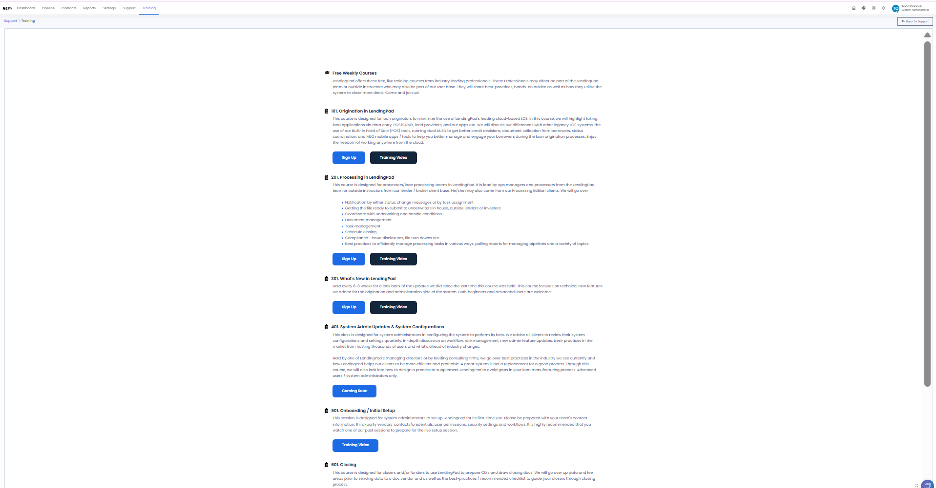
***
INSIDE A ACTIVE LOAN VIEW
